Diesel Leather belt
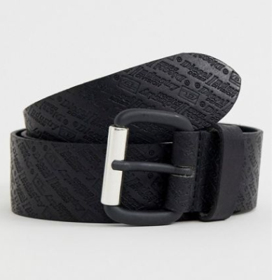
$50.00

Belt by Diesel, A wardrobe staple, Adjustable length, Branded design, Pin-buckle fastening, Top notch, Single keeper, Belt fits true to size, Please buy in your normal trouser size. Changing the denim game since 1978, Diesel celebrates self-expression and individuality with its reinterpreted lifestyle pieces. Ripped-up, washed denim features across a range of jeans and jackets, and when it comes to the brands printed tops and T-shirts, its a case of the bolder, the better. Its accessories make just as much of a statement, too.
Color
Black

